|  |  |  |  |  |  |  |  |  |  |  |  |  |  |  |  |
| --- | --- | --- | --- | --- | --- | --- | --- | --- | --- | --- | --- | --- | --- | --- | --- |
|  |  |  |  |  |  |  |  |  |  |  |  |  |  |  |  |
|  |  |  |  |  |  |  |  |  |  |  |  |  |  |  |  |
|  |  |  |  |  |  |  |  |  |  |  |  |  |  |  |  |
|  |  |  |  |  |  |  |  |  |  |  |  |  |  |  |  |
|  |  |  |  |  |  |  |  |  |  |  |  |  |  |  |  |
|  |  |  |  |  |  |  |  |  |  |  |  |  |  |  |  |
|  |  |  |  |  |  |  |  |  |  |  |  |  |  |  |  |
|  |  |  |  |  |  |  |  |  |  |  |  |  |  |  |  |
|  |  |  |  |  |  |  |  |  |  |  |  |  |  |  |  |
|  |  |  |  |  |  |  |  |  |  |  |  |  |  |  |  |
|  |  |  |  |  |  |  |  |  |  |  |  |  |  |  |  |
|  |  |  |  |  |  |  |  |  |  |  |  |  |  |  |  |
|  |  |  |  |  |  |  |  |  |  |  |  |  |  |  |  |
|  |  |  |  |  |  |  |  |  |  |  |  |  |  |  |  |
|  |  |  |  |  |  |  |  |  |  |  |  |  |  |  |  |
|  |  |  |  |  |  |  |  |  |  |  |  |  |  |  |  |

Snake Fruit Bitmap Plan

* Originally done 16x16, but might be too big compared to the 1 pixel size of snake head
  + Too easy to hit
* Will need to resize it

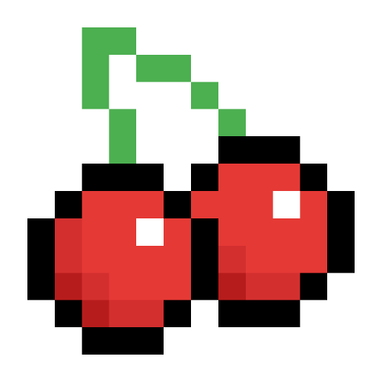

|  |  |  |  |  |  |  |  |
| --- | --- | --- | --- | --- | --- | --- | --- |
|  |  |  |  |  |  |  |  |
|  |  |  |  |  |  |  |  |
|  |  |  |  |  |  |  |  |
|  |  |  |  |  |  |  |  |
|  |  |  |  |  |  |  |  |
|  |  |  |  |  |  |  |  |
|  |  |  |  |  |  |  |  |
|  |  |  |  |  |  |  |  |

Revised smaller fruit